Project Development Phase
Model Performance Test

Date | 03 October 2026
Team ID | SWTID-2026-4339
Project Name | Streamlining IT Procurement: Automating Standard Laptop Orders with Flow Designer
Maximum Marks | 10 Marks

Model Performance Testing:
Project team shall fill the following information in model performance testing template.
S.No. | Parameter | Values | Screenshot
 | Metrics | Regression Model:  N/A. This project is a rule-based Flow Designer workflow, so MAE, MSE, RMSE and R2 score do not apply.  Classification Model:  N/A. No classification model is used, so there is no confusion matrix, accuracy score or classification report. Workflow correctness was checked with UAT instead (see the UAT report). | 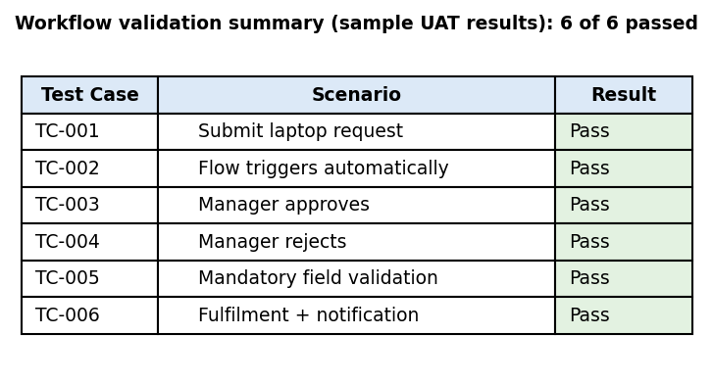
 | Tune the Model | Hyperparameter Tuning - N/A (no machine learning model to tune)  Validation Method - Functional validation through UAT test cases covering approval, rejection and validation paths | 